**Project Name: E-DESK**

**Project Members:**

|  |  |
| --- | --- |
| **PRN No.** | **Name** |
| 220343120031 | Deore Chandrashekhar Sanjay |
| 220343120033 | Patil Dipak Raman |
| 220343120074 | Patil Shubham |
| 220343120114 | Vrushabh Jain |

**Introduction of Project:**

The E-DESK is an online way of lodging complaint via web driven application. The user has to enter & register themselves and lodge a complaint or multiple complaints and he/she gets confirmation on the registered Email Address. The data stored in the database is accessed by authorised authority through web page.

Complaint Portal can be considered to be an efficient alternative to lodge complaints of their areas and get their work done.

**Objective and Scope of Project:**

The E-DESK Forum find it’s scope in various spheres of life:

* The project “E-DESK” is based on creating a web portal service so as to facilitate people to lodge complaints easily.
* The project can be extended in providing a secure and efficient online complaints for people. Citizens may lodge using computers or cell phones. The System is completely secured and anonymous.
* Some way the system is the best choice for using this medium all over the country.

**Modification and improvement over the existing Implementation:**

* Present State : There is no particular website available for Registering Online Complaints in Muncipal Corporations.
* After implementation of project : There will be Website available for Registering Online Complaints in Muncipal Corporations.

**Project Plan:**

No. of User’s and Modules

* **Users-** There will be 2 Users in this Project are as follows-

1. Admin
2. Users

**Modules** -

Modules for E-DESK portal:

1.Complaints management

* + Registration
  + Login
  + Request
  + Acceptance/ Rejection(by Admin)

2.Admin management

* + Accept Complaints
  + Reject Complaints
  + Give Specific Reason for Rejection

3.Feedback Management

* + Get the Response mail after registering complaint
  + Get the Response mail after complaint get accept
  + Get the Response mail after complaint get Rejected

**Technology:**

Frontend- React-JS

Backend- Java Spring-Boot

Database- MySql

Middle-Ware - AXIOS

Others – MS word, MS PowerPoint, etc.

**Roles and Responsibilities:**

|  |  |  |
| --- | --- | --- |
| **Roles And Responsibilities** | | |
| 1 | Role | Frontend, Backend, Testing |
| Member Name | **Deore Chandrashekhar Sanjay** |
| PRN No | 220343120031 |
| Description | Managing Team Work. |
| 2 | Role | Frontend, Backend, Testing |
| Member Name | **Patil Dipak Raman** |
| PRN No | 220343120033 |
| Description | Managing FrontEnd design and middleware Connection. |
| 3 | Role | Frontend, Backend, Testing |
| Member Name | **Patil Shubham** |
| PRN No | 220343120074 |
| Description | Managing Backend |
| 4 | Role | Frontend, Backend, Testing |
| Member Name | **Vrrushabh Jain** |
| PRN No | 220343120114 |
| Description | Managing Backend & Database Design. |

**Data Flow Diagram (DFD):**

Level 0: In this level User create its username and password to get access on the website after the successful login he will able to access website and continue his Complaint registration.

Level1: In this level User will impose his/her complaint with his/her location and Adhhar number and will lodge his/her complaint to specific department.

Then the request will get dispatch to the specified department of Corporation.

Level2: In this level Admin will get notify for the new Request coming from the Users. The Admin of the specified department will either Accept or Reject the Complaint coming from Users

The User will get auto-generated mail for his/her complaint registration and will also get mail for Accept or Reject of complaint.

**ERD / Database Tables:**

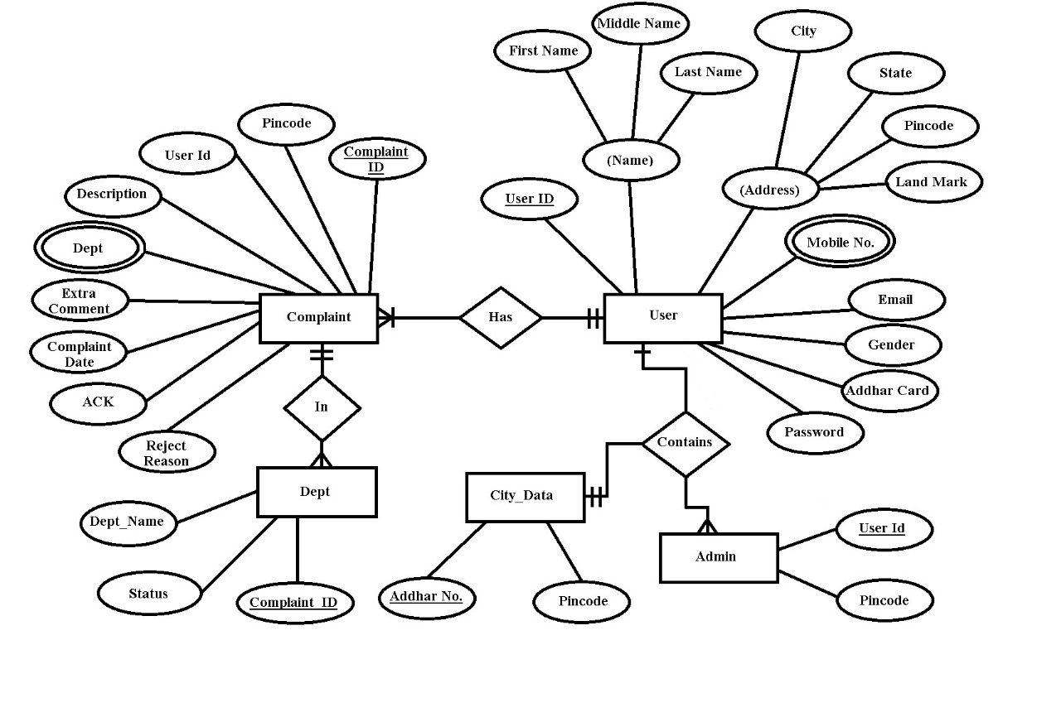

* **Activity Diagram for Admin :-**

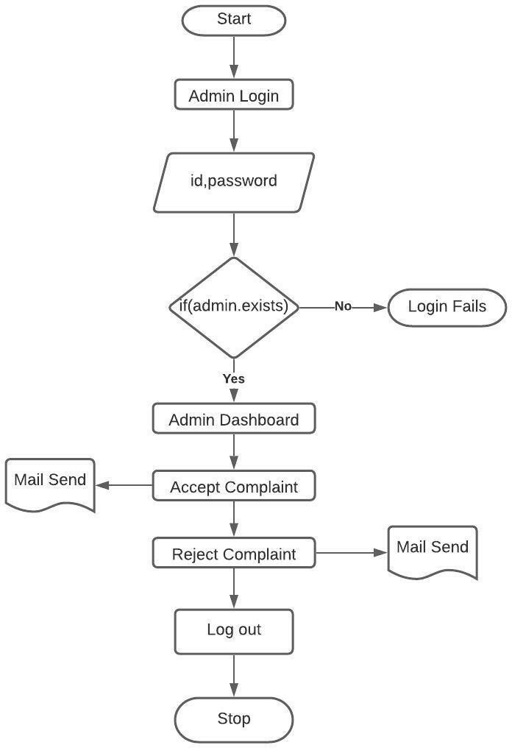

* **Activity Diagram for Users:-**

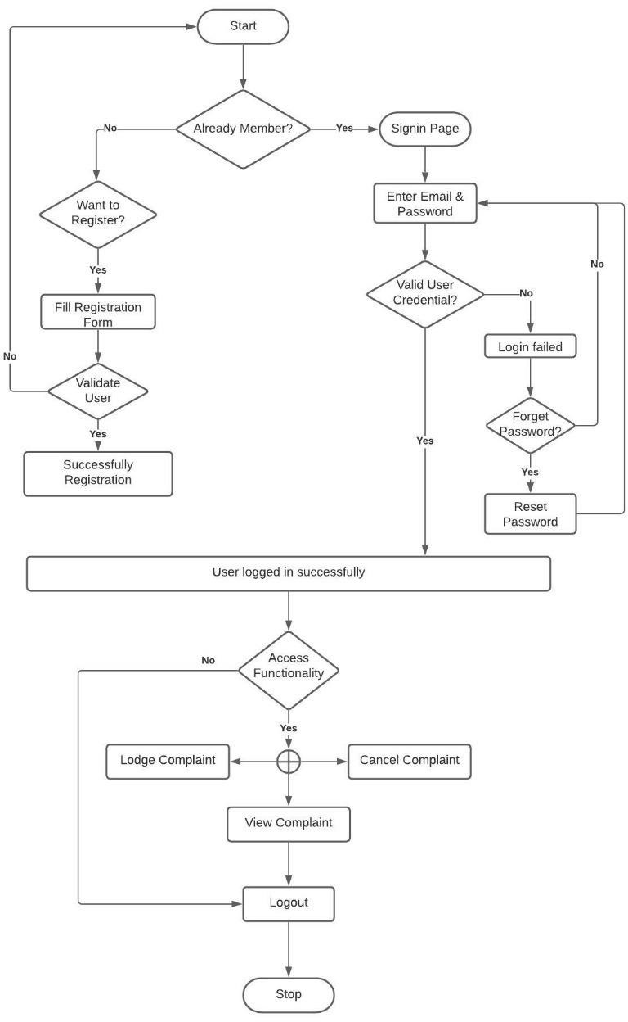

Sequence Diagram:-

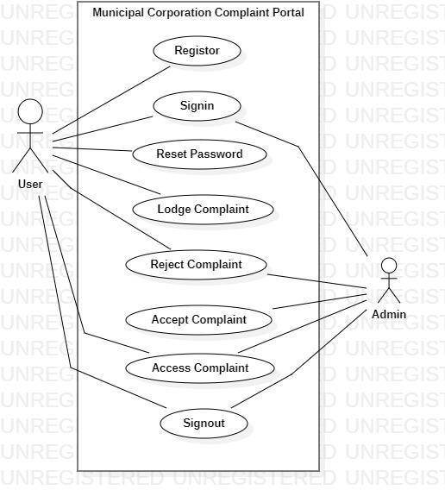

**Future Scope:**

* The E-DESK can be made more secure by using Password Changing.
* The user can be given the privilege of changing the password. So it helps to increase the security of the system.
* Very much Feasible for authorities to pass the complaints to workers.